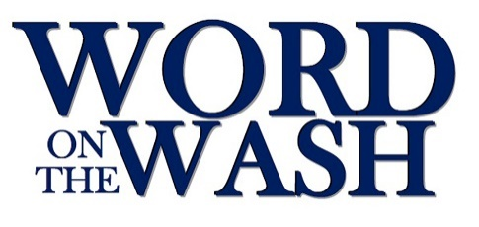

WORD ON THE WASH
HEALTH AND SAFETY STATEMENT

The Word on the Wash Executive Committee undertakes to provide a healthy and safe environment for those attending its events.

In order to do this, it will ensure that:
- there is a sufficient number of stewards who can be easily identified
- risk assessments are in place
- evacuation procedures are known and communicated to those attending
- First Aid cover is provided by suitably qualified person(s)
- any other measures deemed necessary are taken

August 2022

